CMOS | TTL | Request
4049 | 7407 | 1
74HC245 | 74LS245 | 2
74HC138 | 74LS138 | 3
4511 | 7447 | 4
74HC153 | 74153 | 5
AT28C256 |  | 6
GAL16V8PLD |  | 7

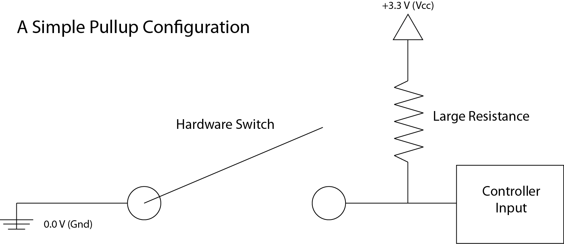

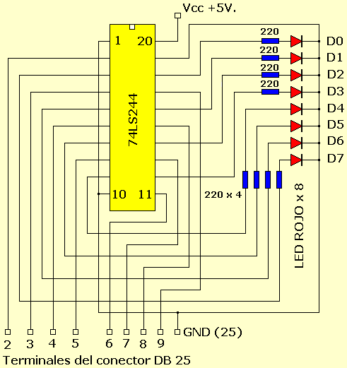

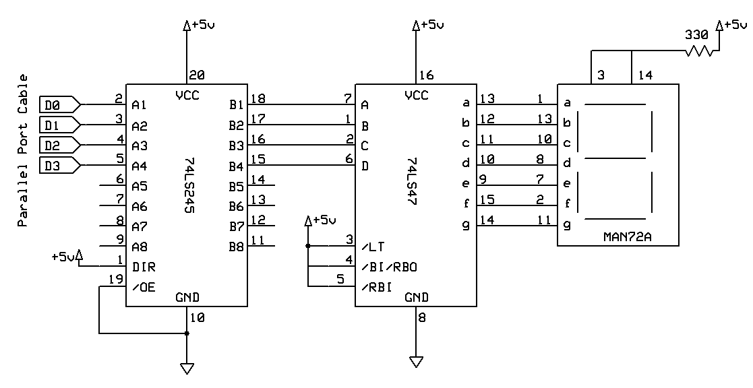

Background and theory on 7-segment display:
The 7-segment display is an LED display that is composed of 7 LED's. When activated in certain arrangements the 7-segment displays can produce numbers and even some letters. The specific 7-segment display being used for the Field Meter project is called the MAN72. In order for each individual LED to be activated, its specific cathode must be set to a low. This is because the MAN72 displays are a common-anode, meaning that when it receives a high output the LED will turn off and when it receives a low output it will turn that specific segment on.

MAN72
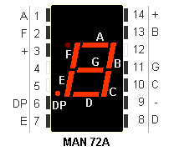
This is a picture of what the MAN72 7-segment display looks like. It also shows its respective input pins as well as its 7 individual LED's labelled with their corresponding letter.
Note: For this project the decimal point (DP) is not used.

Information on GAL16V8 PLD:
The GAL16V8 is a programmable logic device or PLD. For this project this chip acts as the brain for the entire circuit. Its job upon being programmed is to display the correct output on the 7-segment displays. It does this by taking in a 4-bit input and then activating the 7 different displays accordingly.

GAL16V8
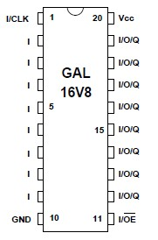
To the left is a picture of the GAL16V8 PLD. As you can see in the picture the GAL16V8 has 20 pins in total. For the Field Meter project pins 2-5 where used as the input pins and pins 12-18 where used as the output pins which connected to the MAN72 7-Segment displays.

TRUTH TABLE INCLUDING INPUT AND OUTPUT VALUES
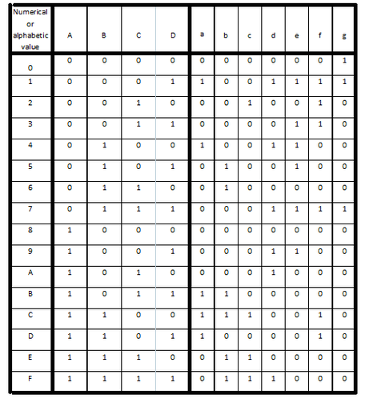
Figure 1
Shown to the right (Figure 1) is the truth table used for the input and outputs of the GAL16V8 PLD.
The A, B, C, and D values represent the input bits from most significant to least significant respectively. On the right side of the table is the output bits a-g, each one representing that specific LED on the 7-Segment display. (See Figure 2 below) Note: When the output bit is a 0 that specific LED is activated and when the output bit is a 1 it is not activated. For example if we look at the number 3, meaning we will need inputs C and D set to on or "high", the output bits required are a, b, c, d, and g set to 0. This is clearly shown for each number and letter that can be displayed. Note: the letters b, c, and d are displayed as lower case on the MAN72 display.

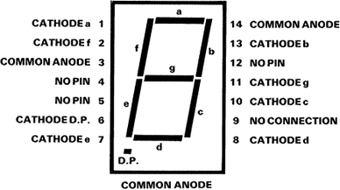
Figure 2

SINGLE 7-SEGMENT DISPLAY ON BREADBOARD
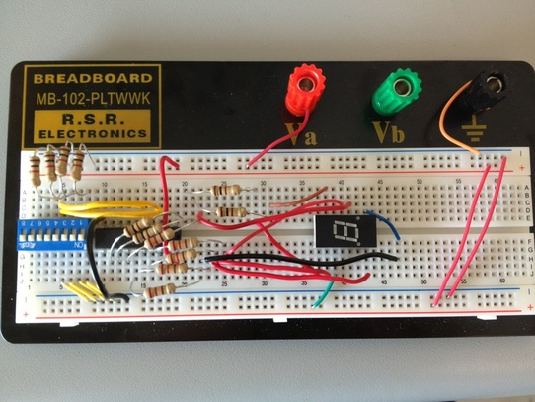
As seen to the left is a picture of the single 7-segment display assembled on a breadboard. The display is connected to the GAL16V8 chip which is connected to the 4 switches. The 4 switches are the input bits for the GAL16V8 chip, which control the number or letter that gets displayed.

BLOCK DIAGRAM
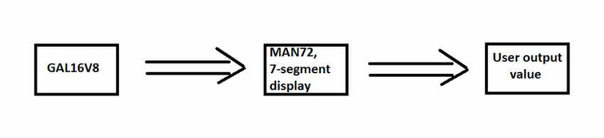

MULTISIM FOR THE SINGLE 7-SEGMENT DISPLAY
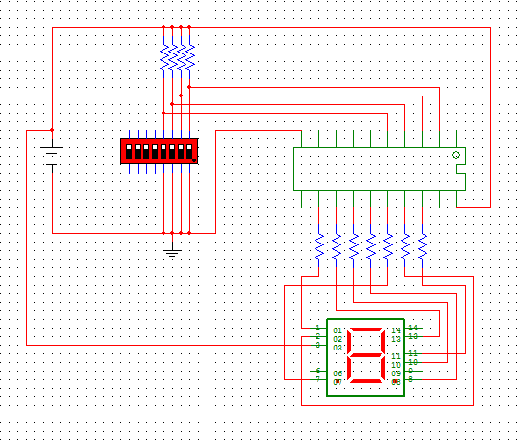
The Multisim schematic shows very clearly the input and output pins used on the GAL16V8 PLD. It also shows the connections from the GAL16V8 to the MAN72 displays clearly as well.
-

